**Topics: Descriptive Statistics and Probability**

1. Look at the data given below. Plot the data, find the outliers and find out $μ, σ, σ^{2}$

|  |  |
| --- | --- |
| **Name of company** | **Measure X** |
| Allied Signal | 24.23% |
| Bankers Trust | 25.53% |
| General Mills | 25.41% |
| ITT Industries | 24.14% |
| J.P.Morgan & Co. | 29.62% |
| Lehman Brothers | 28.25% |
| Marriott | 25.81% |
| MCI | 24.39% |
| Merrill Lynch | 40.26% |
| Microsoft | 32.95% |
| Morgan Stanley | 91.36% |
| Sun Microsystems | 25.99% |
| Travelers | 39.42% |
| US Airways | 26.71% |
| Warner-Lambert | 35.00% |



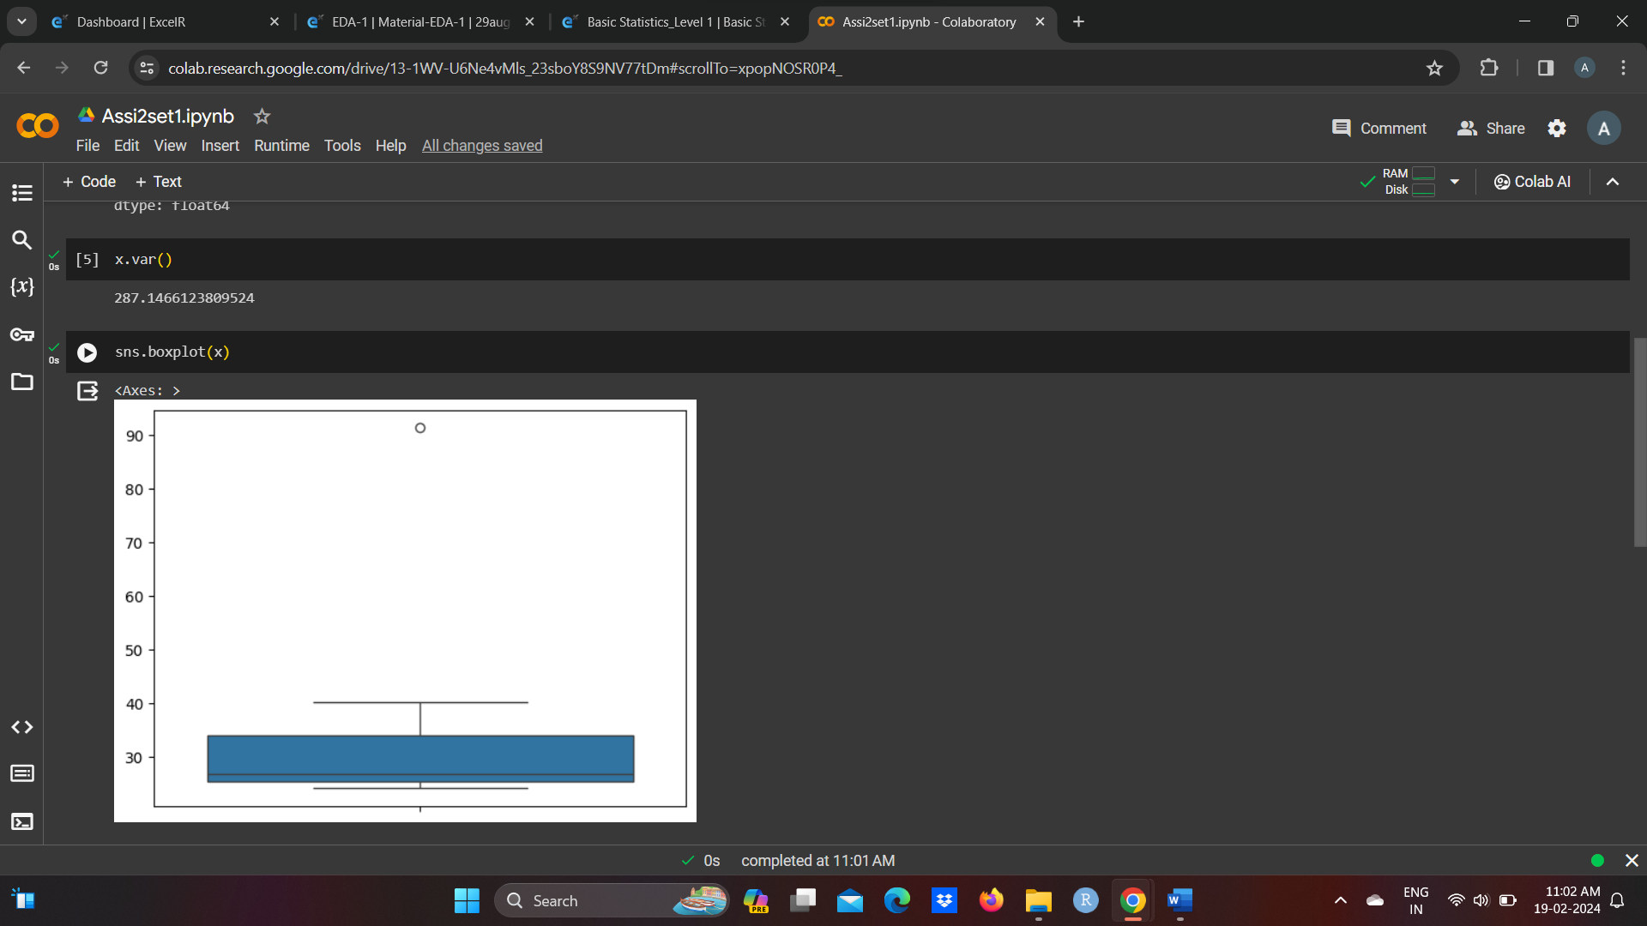



Answer the following three questions based on the box-plot above.

1. What is inter-quartile range of this dataset? (please approximate the numbers) In one line, explain what this value implies.

Ans IQR=Q3-Q1=upper-lower=12-5=7, It means 50% data lie between range 5 and 12

1. What can we say about the skewness of this dataset?

Ans. It is positively skewed data

1. If it was found that the data point with the value 25 is actually 2.5, how would the new box-plot be affected?

Ans. Not be affected because it will affect skewness, The new data will be normally distributed, there will be no skewness in the dataset.



Answer the following three questions based on the histogram above.

1. Where would the mode of this dataset lie?

Ans It should between 5 and 7

1. Comment on the skewness of the dataset.

Ans It is right skewed dataset

1. Suppose that the above histogram and the box-plot in question 2 are plotted for the same dataset. Explain how these graphs complement each other in providing information about any dataset.

Ans. by comparing both of them it is very clear that the data would be positvely skewed.Also, would help us finding mean, mode.

1. AT&T was running commercials in 1990 aimed at luring back customers who had switched to one of the other long-distance phone service providers. One such commercial shows a businessman trying to reach Phoenix and mistakenly getting Fiji, where a half-naked native on a beach responds incomprehensibly in Polynesian. When asked about this advertisement, AT&T admitted that the portrayed incident did not actually take place but added that this was an enactment of something that “could happen.” Suppose that one in 200 long-distance telephone calls is misdirected. What is the probability that at least one in five attempted telephone calls reaches the wrong number? (Assume independence of attempts.)

Ans. Probability of call getting misdirected = (1/200)

Hence probability of call not getting misdirected = 1-(1/200) = 199/200

Number of phone calls attempted = 5

probability that at least one in 5 attempted call reaches the wrong number is : =1-(199/200) ^5

= 0.025

1. Returns on a certain business venture, to the nearest $1,000, are known to follow the following probability distribution

|  |  |
| --- | --- |
| x | P(x) |
| -2,000 | 0.1 |
| -1,000 | 0.1 |
| 0 | 0.2 |
| 1000 | 0.2 |
| 2000 | 0.3 |
| 3000 | 0.1 |

1. What is the most likely monetary outcome of the business venture?

Ans. Max=p=0.3.most likely outcome is 2000

1. Is the venture likely to be successful? Explain

Ans. Yes,because total earning is in the positive 800 and most of earning is 2000

1. What is the long-term average earning of business ventures of this kind? Explain

Ans (x*P(x))

=(-2000*0.1)+(-1000*0.1)+(0*0.2)+(1000*0.2)+(2000*0.3)+(3000*0.1)

=800

1. What is the good measure of the risk involved in a venture of this kind? Compute this measure

Ans The good measure of the risk involved in a venture of this kind depends on the Variability in the distribution. Higher Variance means more chances of risk

Var (X) = E(X^2) –(E(X))^2

= 2800000 – 800^2

= 2160000